Technical Requirements

1. Web Access
2. Database jar Library: mysql-connector-java-8.0.15
3. Mysql local host server port 3306
4. Wizard Software Installer
5. Eclipse IDE
6. JDK 11

Data Dictionary

**Counselor**

A counselor is anyone who has access to the software. Counselor credentials include counselor id, name, date of birth, address, email, phone number.

**Student**

A student is anyone who’s information is entered into the program with the intent to auto generate a schedule. Student credentials include student id, name, counselor, grade level, current classes, gender, email, phone, date of birth, address, emergency contact.

**Teacher**

A teacher is anyone who’s information is entered into the program with the intent of assigning that person to teach a class. Teacher credentials include teacher id, teacher name, teacher subject.

**Teacher Field**

The teacher field refers to the teacher’s field of study. This is represented by a string that can be but is not limited to MATH, ENGLISH, SCIENCE, HISTORY, etc.

**Student Grade Level**

The student grade level refers to the student’s class status at the school. This is represented by a string which can only be the following: SIXTH, SEVENTH, EIGHTH, FRESHMAN, SOPHOMORE, JUNIOR, and SENIOR.

**Class**

The ‘class’ term refers to a single class with one student assigned to it and has a capacity. Classes can only be created by a counselor. The following fields are required to create a class: CLASS ID, CLASS NAME, TEACHER, ASSISTANT TEACHER, CLASS CAPACITY, and CLASS PERIOD. A counselor may set restrictions to a class when created. These restrictions include student grade level restrictions (i.e. sophomore only) and gender restrictions.

Use Case Scenarios

New Teacher:

* The counselor chooses to create a new teacher.
* The new-teacher menu is displayed.
* If all required fields are entered correctly, add the teacher to the database.
* The counselor is brought back to the main menu.

New Student:

* The counselor chooses to create a new student.
* The new-student menu is displayed.
* The counselor is prompted to enter the new student’s information.
* If all required fields are entered correctly, add the student to the database.
* The counselor is brought back to the main menu.

New Class:

* The counselor chooses to create a new class.
* The new-class menu is displayed.
* The counselor is prompted to enter all the class information.
* If all required fields are entered correctly, then add the class to the database.
* The counselor is brought back to the main menu.

Use Case Scenarios Cont.

Generate Schedule:

* The counselor chooses to auto-generate a schedule.
* The scheduling menu is displayed.
* The counselor is prompted to enter the student_id they would like to auto-generate a schedule for.
* The scheduling algorithm is initiated.
* The counselor is notified of the number of scheduling conflicts.
* The counselor views the schedule for any necessary edits.
* The counselor saves and prints the schedule.
* The counselor is brought back to the main menu.

View Schedule:

* The counselor chooses to view a schedule.
* The view-schedule menu is displayed.
* The counselor is prompted to enter the student’s ID number.
* If the ID is valid, the student’s schedule is displayed.
* The counselor makes any necessary edits.
* The counselor saves and prints the edited schedule.
* The counselor is brought back to the main menu.

Database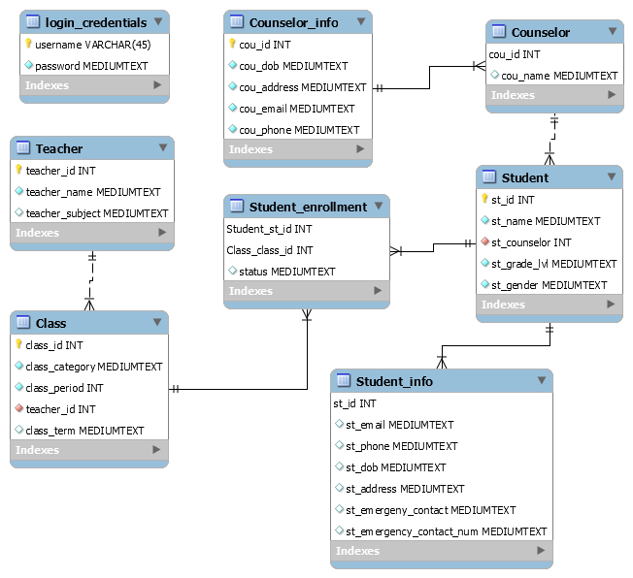

Class Diagram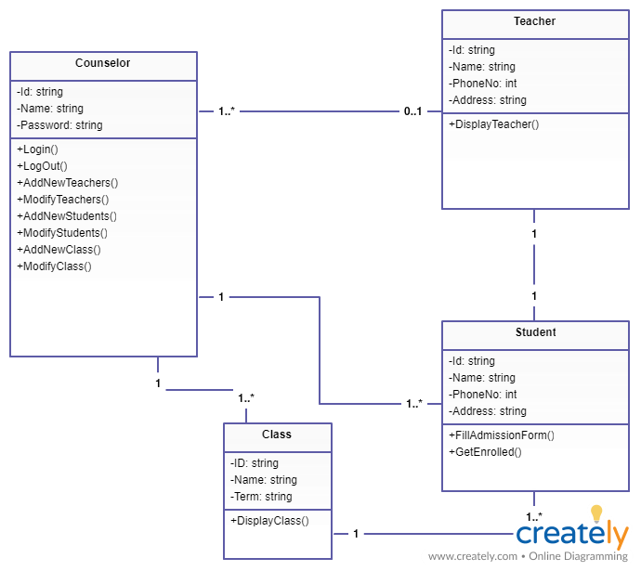

Use Case Diagram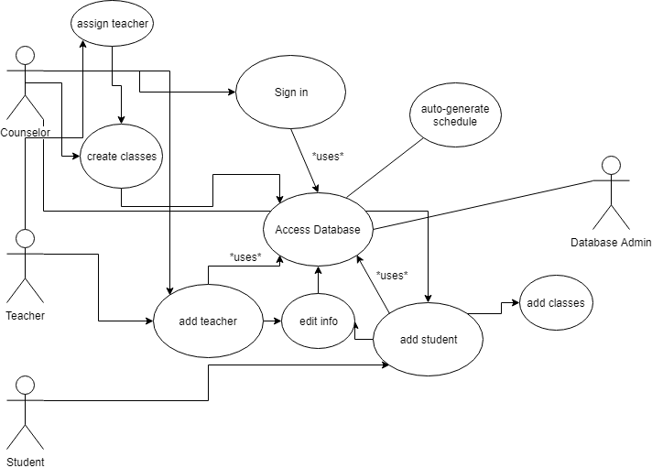

Design Diagram